**Brand Name : INTERWOOD**

Kids chairs

# Study Chair Willow For Kids

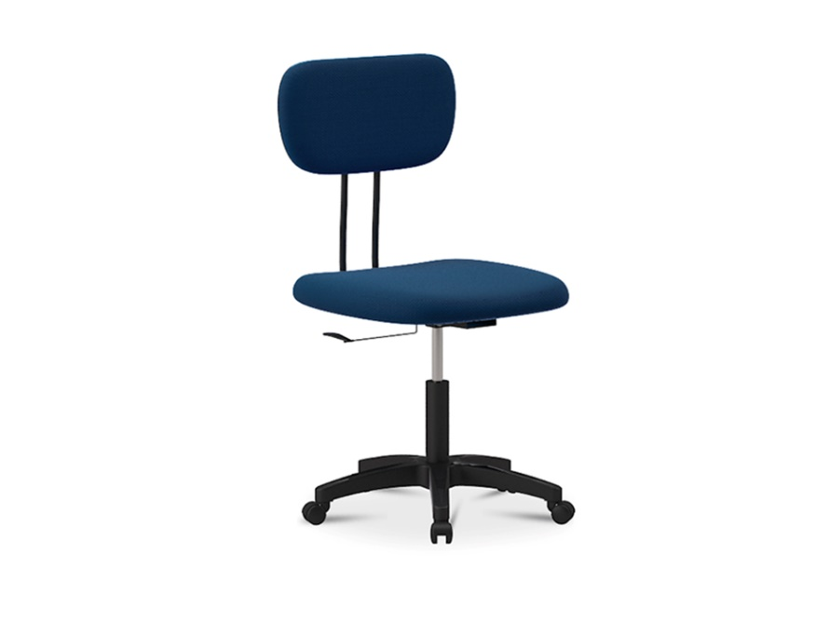**Description :**

* Size: 560 DIA X 86 0H (mm)
* Base in a black colour high quality plastic
* Seat and back upholstered in high quality foam and fabric

**Rs. 13,500**